

Hotel Reservation Operations Analytics
MySQL Business Analytics Project

Project Introduction
StayPoint Hospitality is a hotel chain operating multiple properties across different cities. Each hotel offers rooms of varying types, and guests make bookings that are fulfilled as stays managed by front-desk and housekeeping staff. The Operations and Guest Experience teams want to use data to understand booking demand, guest behaviour, stay outcomes, and staff and room utilization.
You will work as a Data Analyst supporting the Operations team. Your task is to understand the business, understand the data model, build the database, analyse the data using MySQL, and communicate meaningful business insights.

Sprint 1: Business Understanding and Data Understanding

1.1 Company Background
Understand the company's business, the nature of hotel reservation operations, and the business context behind the analysis.

1.2 Role
Assume the role of a Data Analyst supporting the Operations team. Your responsibility is to use the available data to answer business questions and support operational decisions.

1.3 Understanding the ER Diagram
Study the ER diagram carefully before accessing the database. Understand the tables, columns, primary keys, foreign keys, and relationships.
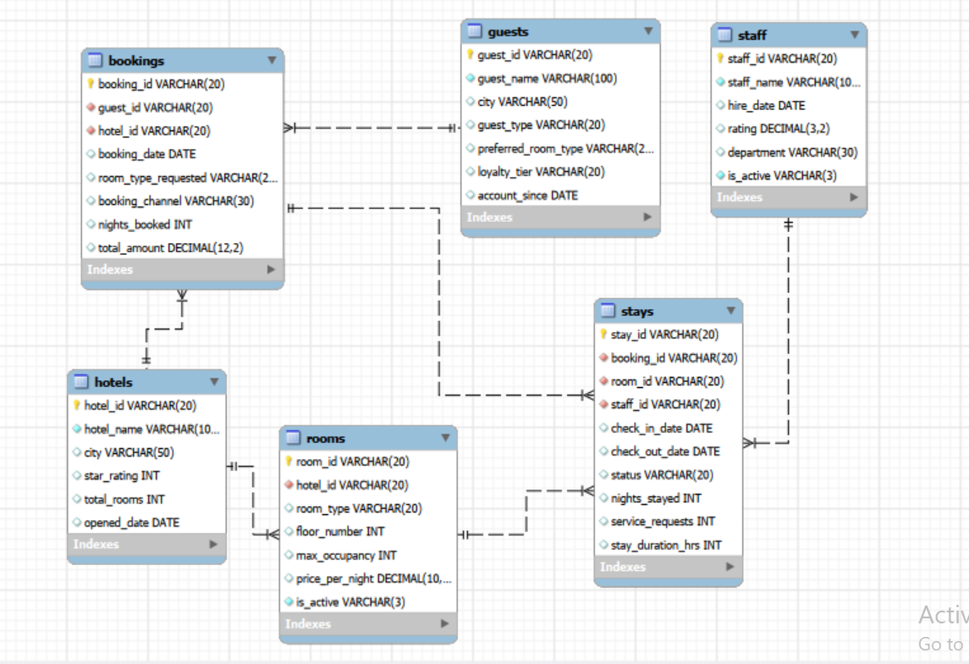
Figure 1: Hotel Reservation database ER diagram

1.4 Analytical Thinking from the ER Diagram
Before accessing the database or writing SQL queries, use the ER diagram to plan how you would investigate each business situation.
- Do not write SQL queries at this stage.
- For each situation, identify the tables and columns you would need.
- Explain how the required tables are related.
- Describe what information you would compare or examine and the logical flow you would follow.

1. Management wants to find guests who have made multiple bookings. What information would you need to identify them?
2. The Operations team wants to identify stays that were checked in but later marked as no-show or cancelled. Where would you find the information needed to investigate this?
3. The Guest Experience team wants to compare Individual and Corporate guests based on their booking activity. Which tables and columns would you need?
4. The Operations team wants to compare different booking channels based on how many nights guests stay and how much they spend. Which tables would you need to connect?
5. The team wants to identify which staff members have handled stays and examine their recorded ratings. What information would you need?
6. Operations wants to understand whether different room types are being booked for different stay durations. Which tables and columns would you need?
7. Management wants to compare booking performance across different hotels. What information would you need from the database?
8. The Operations team wants to investigate whether larger room capacities are associated with higher service requests during a stay. Which information would you need, and where would you find it?
9. Management wants to understand whether stay outcomes differ across booking channels. What tables and information would you bring together?
10. The Operations team wants to understand which guests have made bookings and how their stays are being handled. What information would you need to connect a guest with their bookings and stays?

Sprint 2: Database Setup

2.1 Design the Database from the ER Diagram
Using the provided ER diagram as your blueprint, create the database and tables in MySQL. The table-creation queries are not provided.
- Choose appropriate data types.
- Define primary keys.
- Define foreign keys.
- Apply essential constraints such as NOT NULL, UNIQUE, and DEFAULT where appropriate.
- Create tables in an appropriate order based on their dependencies.

2.2 Data Import
Import the provided CSV files into the respective MySQL tables and verify that the data has been loaded correctly. MySQL Import Wizard may be used.

Dataset Overview
Table | Rows | Columns
guests | 350 | 7
hotels | 25 | 6
rooms | 600 | 7
bookings | 2,800 | 8
stays | 3,200 | 10
staff | 70 | 6

Sprint 3: Basic Analysis / Data Exploration
Write SQL queries to answer the following basic questions. The purpose of this sprint is to become familiar with the database before moving into objective-based analysis.
1. What is the total number of guests?
2. What is the total number of bookings?
3. What is the total number of stays?
4. What are the different room types available?
5. How many staff members are currently active?
6. What are the different booking channels?
7. What is the total booking amount across all bookings?
8. What is the average nights booked per booking?

Sprint 4: Objective-Based Analysis
For each objective, understand the business requirement, formulate your own analytical questions, determine the required data, write multiple meaningful SQL queries, interpret the results, and record your business insights.

4.1 Understand Booking Demand
Business Objective: The Operations team wants to understand where and how bookings are being generated.

Things to Consider While Analyzing:
- Compare the number of bookings across hotels.
- Compare bookings across different booking channels.
- Compare bookings based on room type requested.
- Examine how booking volume changes over time.
- Look at the booking amount across different groups.
Formulate the analytical questions required to address the objective and support your analysis with multiple meaningful SQL queries. The points above are starting points, not predefined SQL questions.

4.2 Understand Guest Booking Behaviour
Business Objective: The Guest Experience team wants to understand how guests are using the reservation service.

Things to Consider While Analyzing:
- Compare guests based on the number of bookings they make.
- Identify guests with a higher total booking amount.
- Compare guest activity across hotels.
- Look at differences between Individual and Corporate guests.
- Examine guest booking patterns over time.
Formulate the analytical questions required to address the objective and support your analysis with multiple meaningful SQL queries. The points above are starting points, not predefined SQL questions.

4.3 Evaluate Stay Performance
Business Objective: The Operations team wants to understand how well stays are being completed.

Things to Consider While Analyzing:
- Compare stay outcomes across different hotels (hotel information is on the bookings table, so you will need to connect bookings and stays).
- Examine stay duration.
- Compare stay outcomes by status (Checked-out, No-show, Cancelled, In-progress) — these are not a simple success/failure split, so consider what each status actually represents.
- Identify hotels with higher booking activity or poorer outcomes.
- Compare stay performance over time.
Formulate the analytical questions required to address the objective and support your analysis with multiple meaningful SQL queries. The points above are starting points, not predefined SQL questions.

4.4 Understand Staff and Room Performance
Business Objective: The Operations team wants to understand how its hotel resources are being utilized and how they are performing.

Things to Consider While Analyzing:
- Compare the number of stays handled by staff members.
- Compare staff performance across stay outcomes.
- Examine stay duration across staff members.
- Compare room usage across different room types.
- Look at stay performance across different rooms.
Formulate the analytical questions required to address the objective and support your analysis with multiple meaningful SQL queries. The points above are starting points, not predefined SQL questions.

4.5 Identify Booking and Stay Problems
Business Objective: The Operations team wants to understand why some bookings require additional effort or fail to result in a completed stay.

Things to Consider While Analyzing:
- Examine which bookings resulted in cancellations or no-shows.
- Identify common stay statuses and problem patterns.
- Compare stay performance for bookings with high service request counts.
- Examine whether certain hotels experience more booking problems.
Formulate the analytical questions required to address the objective and support your analysis with multiple meaningful SQL queries. The points above are starting points, not predefined SQL questions.

SQL Deliverable
- ER diagram interpretation and Sprint 1.4 logical solutions.
- MySQL database created from the provided ER diagram.
- Imported and verified project data.
- SQL queries for Sprint 3.
- Your analytical questions for each Sprint 4 objective.
- Supporting SQL queries for each objective.
- Findings and business insights.
- Final conclusions and recommendations wherever appropriate.

Final Outcome
By completing this project, you should be able to move from a business requirement to a data-driven answer: understand the business problem, reason from a data model, plan an analytical solution, build a relational database, formulate questions, write SQL queries, interpret results, and communicate meaningful business insights.

